# Release Information

|  |  |
| --- | --- |
| *Release* | *Deployment* |
| *Leader* | *Nathan Kawula* |
| *SVN Revision Number* | *4* |

Monthly reports will generate once the first day of a new month has been met and an undo/redo feature has been added for the creation of new transactions and new categories and the editing of a transaction. Also, bugs regarding automatic transactions were fixed from iteration 3. General UI design has been reworked as well.

# Progress

|  |  |  |  |
| --- | --- | --- | --- |
| **Stories and spike solutions worked on during this release** | | | |
| **Story, Spike** | **Description** | **% Impl.** | **Notes, plan for completion** |
| *SNAL-12* | *Edit Past Transactions* | *100%* | *Complete* |
| *SNAL-24* | *Automatic Transactions* | *100%* | *Complete* |
| *SNAL-21* | *Pay-Period Calculation* | *100%* | *Complete* |
| *SNAL-22* | *Pay Settings* | *100%* | *Removed as parallel with automatic transaction behavior* |
| *SNAL-26* | *Log Out* | *100%* | *Complete* |
| *SNAL-8* | *Monthly Reports* | *100%* | *Complete* |
| *Other* | *Undo/Redo* | *75%* | *Additional features to be implemented and bugs to be resolved* |
| *Other* | *Updating Forms* | *100%* | *Completed for deployment* |
| *Other* | *Fixing Database* | *100%* | *Category section completed* |

|  |  |  |  |
| --- | --- | --- | --- |
| **Test Coverage Report** | | | |
| **Src code file** | **% Coverage** | **Non-covered** |
| addCategoryCommand.cs | *0%* | *NA* |
| AddTransactionCommand.cs | *0%* | *NA* |
| AutomaticList.cs | *0%* | *NA* |
| CancelAutoForm.cs | *0%* | *Form* |
| Category.cs | *100%* | *NA* |
| CategoryList.cs | *100%* | *NA* |
| Command.cs | *0%* | *NA* |
| DatabaseManager.cs | *75%* | *Applicable to outdated resource* |
| Date.cs | *100%* | *NA* |
| EditTransactionCommand.cs | *0%* | *NA* |
| EditTransactionForm.cs | *0%* | *Form* |
| Handler.cs | *0%* | *NA* |
| History.cs | *0%* | *NA* |
| LoginForm.cs | *0%* | *Form* |
| LoginManager.cs | *100%* | *NA* |
| MoneyBeeForm.cs | *0%* | *Form* |
| MoneyBeeProgram.cs | *0%* | *NA* |
| Notifications.cs | *100%* | *NA* |
| RegisterForm.cs | *0%* | *Form* |
| RegistrationManager.cs | *100%* | *NA* |
| RemoveCategoryCommand.cs | *0%* | *NA* |
| Transaction.cs | *100%* | *NA* |
| TransactionForm.cs | *0%* | *Form* |
| TransactionHistory.cs | *100%* | *NA* |
| TransactionManager.cs | *0%* | *NA* |
| User.cs | *100%* | *NA* |

|  |  |  |
| --- | --- | --- |
| **Accomplishments by engineer** | | |
| **Team Member** | **Total Time (hrs)** | **Stories, Spikes implemented** |
| *Sammy E.* | *11.3* | *SNAL-12/21/22* |
| *Andi F.* | *11.5* | *SNAL-24* |
| *Nathan K.* | *17.8* | *SNAL-8, Other: Updating Forms* |
| *Logan T.* | *17.3* | *SNAL-12/26, Other: Undo/Redo, Fixing Database* |
| TEAM TOTAL | ***57.9*** |  |

|  |  |
| --- | --- |
| **Document updates** | |
| **Document** | **Changes** |
| *README.txt* | *Updated contents to match deployment requirements* |
| *Money Bee Forms* | *Updated UI* |
| *CDD* | *Updated for deployment* |
| *.cs files for undo/redo* | *Created* |

# Issues

Document anything that is not decided yet and needs to be resolved at some point.

|  |  |  |  |  |
| --- | --- | --- | --- | --- |
| **Issue Number** | **Discovery**  **Date** | **Resolution**  **Date (Est.–Act.)** | **Responsible Person** | **Description (Prob / Resolution)** |
| Multiple | 5/17 | Unknown | Multiple | See README.txt’s Known Bug/Deficiencies for description |

# Screen Shots

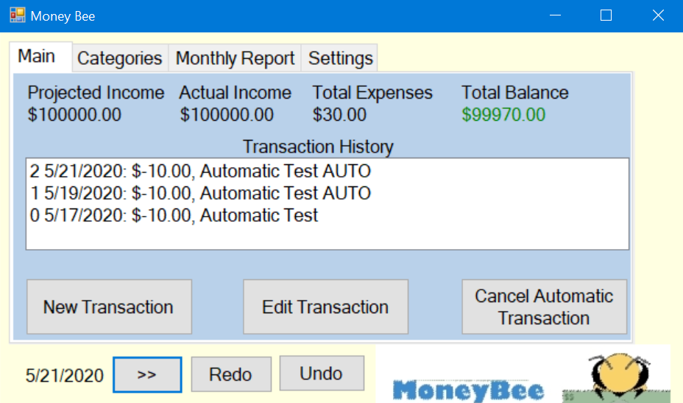

Screenshot to show functionality of automatic transaction as well as UI update

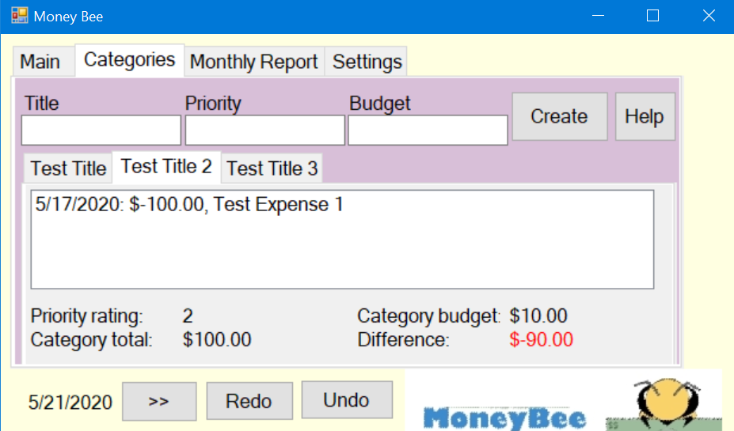

Screenshot to show product of undo and redo operation (A total of 6 categories and 1 transaction were made, this was undone to empty the category list/transaction, and redone to return 3 categories and transaction) More details about redo/undo can be found in the demonstrational video of HW2. UI updates shown as well.

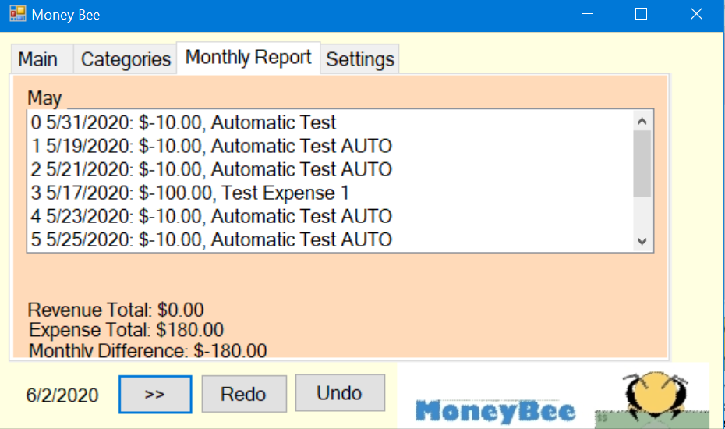

Screen shot of monthly report of May

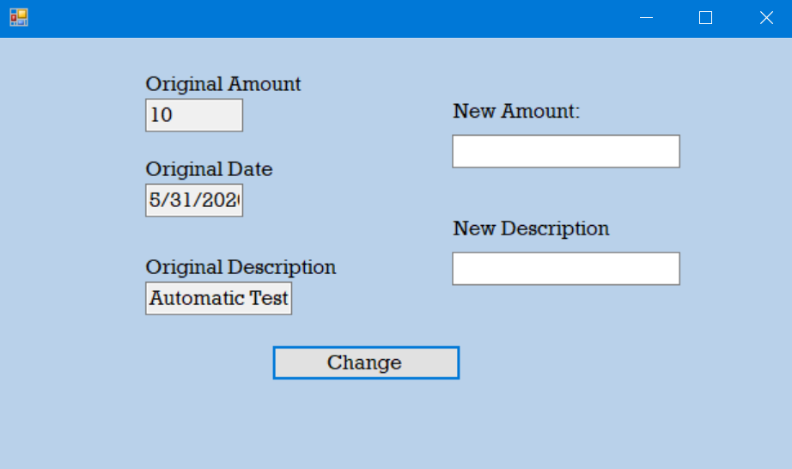

Screenshot of edit transaction form. Returns edited amount/description of selected item in history.

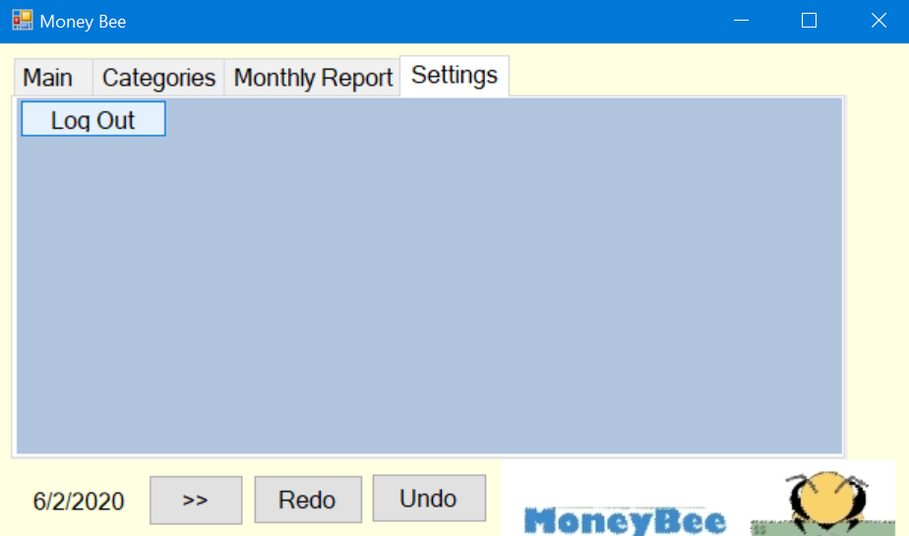

Updated UI of settings tab. Removed unneeded buttons